Phenotype Recording Instrument User’s Guide
I. Phenotype Recording Instrument
1. Direct Web browser to: https://ds9.rockefeller.edu:444/pri/
2. To log in, complete the following fields:
A. Guests: To take a practice questionnaire…
1) Click the radio button labeled “Log in as a guest, for a trial questionnaire.”
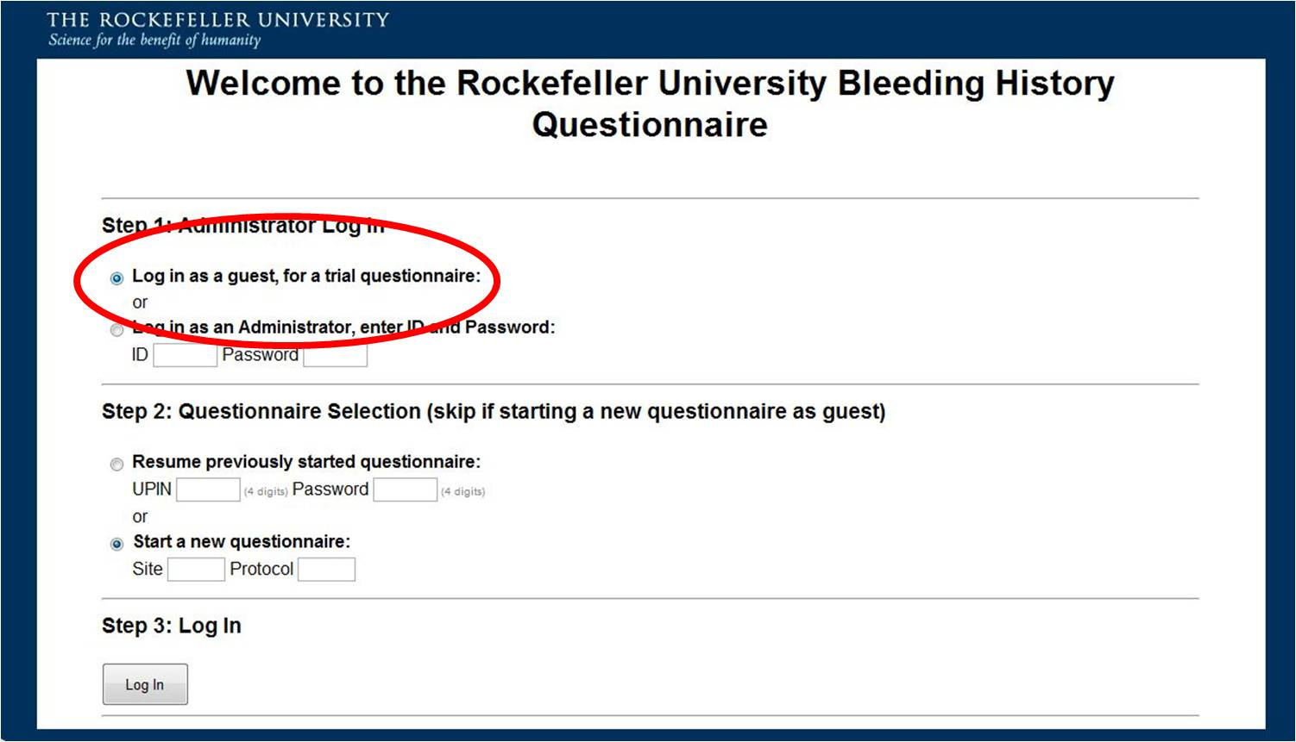
2) Click the radio button labeled “Start a new questionnaire.” Leave the “Site” and “Protocol” boxes blank.
3) Click “Log In.”
3. To complete the questionnaire:
A. To start the questionnaire, click “General Information.” The Web browser will be automatically directed to the first question block.
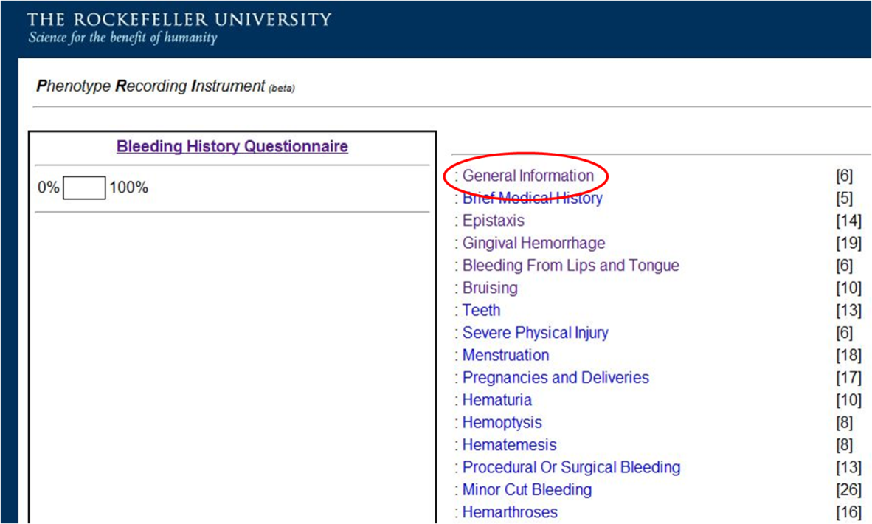
B. To complete a specific question block, click the link to the desired block.
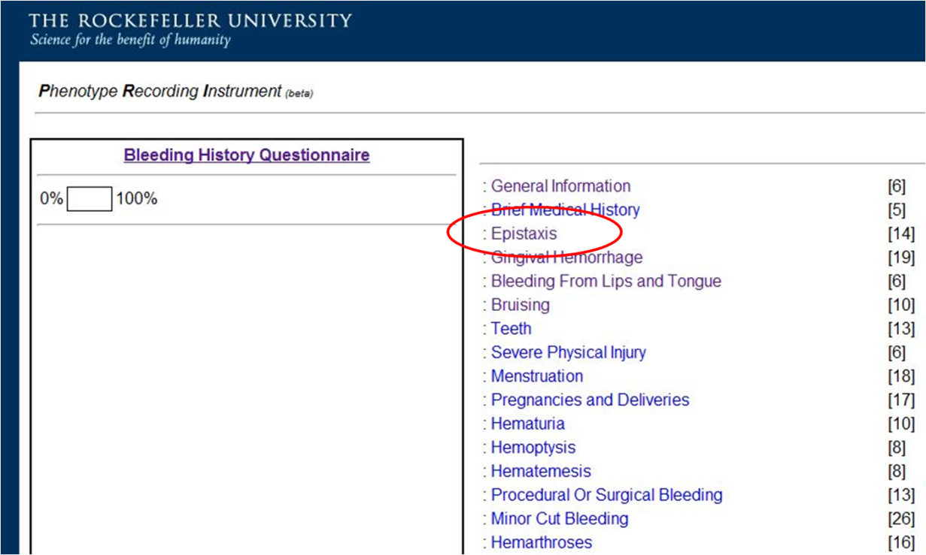
C. To log out at any time, click “log out” in the top right corner.

D. The UPIN for the questionnaire underway is displayed in the top right corner.

E. The time elapsed since the start of the questionnaire is indicated in the top right corner.

F. To skip to a new question block at any time, click “Bleeding History Questionnaire” in the left sidebar. The next screen will display the list of question blocks. Completed question blocks are indicated by a strikethrough bar. On this screen, the percentage of completed questions is displayed in the left sidebar.

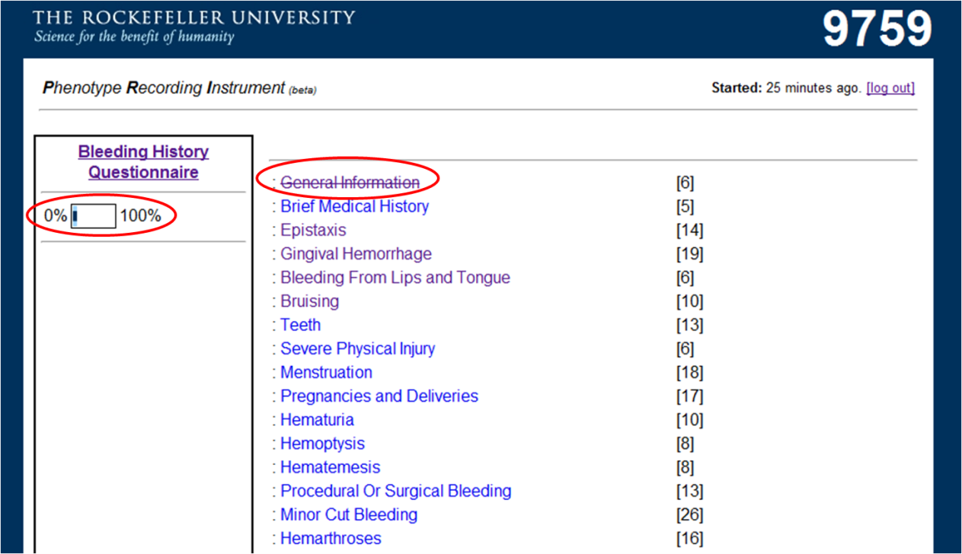
G. To answer a question, click the radio button or check box next to the appropriate answer, or fill out the appropriate box for free-text responses.

H. When a question is complete, click “Next” to proceed to the next question.

I. To correct an entered question response, click the “back” button on the web browser until the browser cycles back to the desired question. Change the answer and click “Next.” The previous answer will be erased from the database.

J. To erase all the data within a question block and return to the beginning of the block, click “Restart.”

K. To review completed question responses, click “Review.”

